AI-BASED TIMETABLE GENERATION SYSTEM

DAY 1 – PROJECT TITLE FINALIZATION

Project Title
AI-Based Timetable Generation System

Project Overview
The AI-Based Timetable Generation System automates timetable creation for educational institutions. It helps schedule subjects, faculty, and classrooms without conflicts. The system reduces manual effort, improves scheduling efficiency, and ensures proper allocation of resources.

Outcome
- Project title finalized.
- Project scope identified.

DAY 2 – REQUIREMENT GATHERING

Problem Statement
Manual timetable preparation is time-consuming and may lead to scheduling conflicts. Educational institutions often face challenges in allocating faculty, classrooms, and subjects efficiently. The proposed system automates timetable generation and minimizes scheduling issues.

Requirements

Functional Requirements
- Login
- Faculty Management
- Subject Management
- Timetable Generation
- Timetable Viewing

Non-Functional Requirements
- Security
- Reliability
- User-Friendly Interface

Outcome
- Requirements document prepared.

DAY 3 – OBJECTIVE DEFINITION

Objectives
- Automate timetable generation.
- Reduce scheduling conflicts.
- Manage faculty and subjects efficiently.
- Improve timetable accuracy.
- Save administrative time.

Outcome
- Objectives finalized.

DAY 4 – USER & MODULE IDENTIFICATION

Users

Admin
- Manage faculty
- Manage subjects
- Generate timetable

User
- View timetable

Modules
- Login Module
- Faculty Module
- Subject Module
- Timetable Generation Module
- Timetable View Module

Outcome
- User roles and modules identified.

DAY 5 – USE CASE DIAGRAM PREPARATION

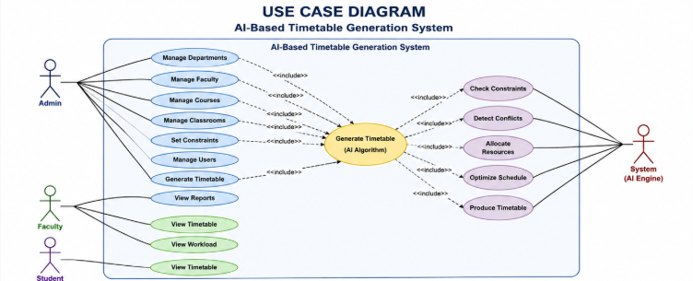

Use Cases

Admin
- Login
- Add Faculty
- Add Subject
- Generate Timetable

User
- View Timetable

Outcome
- Use Case Diagram completed.

DAY 6 – DATABASE REQUIREMENT ANALYSIS

Tables Required

Faculty
- Faculty_ID
- Faculty_Name

Subject
- Subject_ID
- Subject_Name

Classroom
- Room_ID
- Room_Name

Timetable
- Timetable_ID
- Day
- Time
- Faculty_ID
- Subject_ID

Outcome
- Database requirements analyzed.

DAY 7 – ER DIAGRAM DESIGN

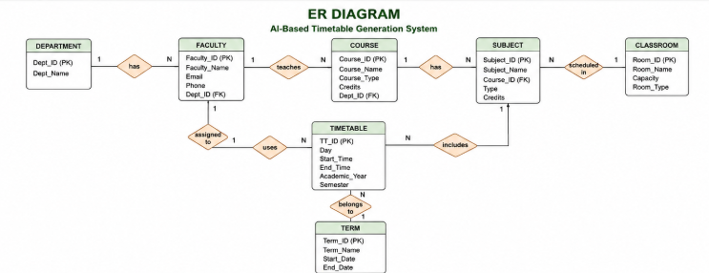

Entities
- Faculty
- Subject
- Classroom
- Timetable
- Department
- Course
- Term

Relationships
- Faculty teaches Subject.
- Subject assigned to Timetable.
- Classroom allocated for Timetable.

Outcome
- ER Diagram designed.

DAY 8 – DATABASE SCHEMA CREATION

Schema Design

Faculty Table
- Faculty_ID (PK)
- Faculty_Name

Subject Table
- Subject_ID (PK)
- Subject_Name

Classroom Table
- Room_ID (PK)
- Room_Name

Timetable Table
- Timetable_ID (PK)
- Faculty_ID (FK)
- Subject_ID (FK)
- Room_ID (FK)

Outcome
- Database schema completed.

DAY 9 – LOGIN PAGE DESIGN

Page 1: Login Page

Components
- Username Textbox
- Password Textbox
- Login Button

Features
- User Authentication
- Input Validation

Outcome
- Login page wireframe prepared.

DAY 10 – DASHBOARD DESIGN

Page 2: Dashboard

Components
- Total Faculty Count
- Total Subjects Count
- Generate Timetable Button
- Navigation Menu

Features
- Quick access to all modules
- Summary information display

Outcome
- Dashboard UI completed.

DAY 11 – FACULTY & SUBJECT MANAGEMENT PAGE

Page 3: Faculty and Subject Management

Faculty Section
- Add Faculty
- View Faculty

Subject Section
- Add Subject
- View Subject

Features
- Create, Read, Update and Delete (CRUD) operations

Outcome
- Management page designed.

DAY 12 – TIMETABLE GENERATION PAGE

Page 4: Generate Timetable

Components
- Select Department
- Select Semester
- Generate Button

Features
- Automatic timetable generation
- Conflict checking mechanism

Outcome
- Timetable generation page completed.

DAY 13 – TIMETABLE VIEW PAGE

Page 5: View Timetable

Components
- Timetable Table
- Day-wise Schedule
- Subject Details
- Faculty Details

Features
- Easy timetable viewing
- Organized schedule display

Outcome
- Timetable display page completed.

